1.1 Assumptions
- Facility Expansion Capacity
  - Each existing facility $f$ can expand its 0–12 capacity up to 220% of its original size (final capacity $≤2.2n_{f}$).
  - Expansion is divided into two piecewise segments:
    - Segment 1 (0–100%): $x_{1,f}≤n_{f}$ ​
    - Segment 2 (100–120%): $x_{2,f}≤0.2n_{f}$ ​
    - The binary variable $b_{f}$ indicates whether expansion beyond 100% occurs.
- Cost Structure
  - The total expansion cost increases nonlinearly with the scale of expansion:
$${\text{Cost}}_{f}^{\text{exp}}=\left(20000+200n_{f}\right)\left(\frac{x_{1,f}+x_{2,f}}{n_{f}}\right)+\left(20000+200n_{f}\right)b_{f}$$
The first term reflects proportional variable costs that satisfied the expansion of larger facility is cheaper, and the second term is a one-time fixed fee incurred when the second expansion stage is activated.
  - Equipment cost for 0–5 capacity is $100 per slot (applies to both new builds and expansions).
  - New facility construction cost depends on facility type t$∈${small, medium, large}:
$${\text{BuildCost}}_{t}=\left\{\begin{aligned}65000,& \text{if small (100 total, 50 for 0-5)} \\ 95000,& \text{if medium (200 total, 100 for 0-5)} \\ 115000, & \text{if large (400 total, 200 for 0-5)}\end{aligned}\right.$$
- Demand Estimation Rules
  - A ZIP code is defined as high-demand if average income ≤ $60,000 or employment rate ≥ 60%.
  - Required childcare slots are estimated as:
$${\text{req}}_{0-12,z}=\left\{\begin{aligned}0.5×{\text{pop}}_{0-12,z},& \text{if high-demand} \\ \frac{1}{3}×{\text{pop}}_{0-12,z}, & \text{otherwise}\end{aligned}\right.$$
$$\text{and} {\text{req}}_{0-5,z}=\frac{2}{3}×{\text{pop}}_{0-5,z}$$
  - All demand and capacity data are aggregated at the ZIP-code level.
1.2 Decision Variables
Variable | Type | Description
$$y_{z,t}$$ | Integer | Number of new facilities of type $t$ built in ZIP $z$
$$x_{1,f}$$ | Continuous | Expansion amount within 0–100% of base capacity
$$x_{2,f}$$ | Continuous | Additional expansion (100–120%)
$$b_{f}$$ | Binary | Indicator variable for expansion beyond 100%
$${z05_build}_{z,t}$$ | Continuous | Number of 0–5 slots in new facilities
$${z05_expand}_{f}$$ | Continuous | Number of 0–5 slots added via expansion

1.3 Objective Function
$$\min{Total Cost}=\sum_{z,t}{{\text{BuildCost}}_{t}}· y_{z,t}+100\sum_{z,t}{{z05_build}_{z,t } + 100\sum_{f}{{z05_expand}_{f}+\sum_{f}{\left(20000+200n_{f}\right)(\frac{x_{1,f}+x_{2,f}}{n_{f}})}+ \sum_{f}{\left(20000+200n_{f}\right)b_{f}}}}$$

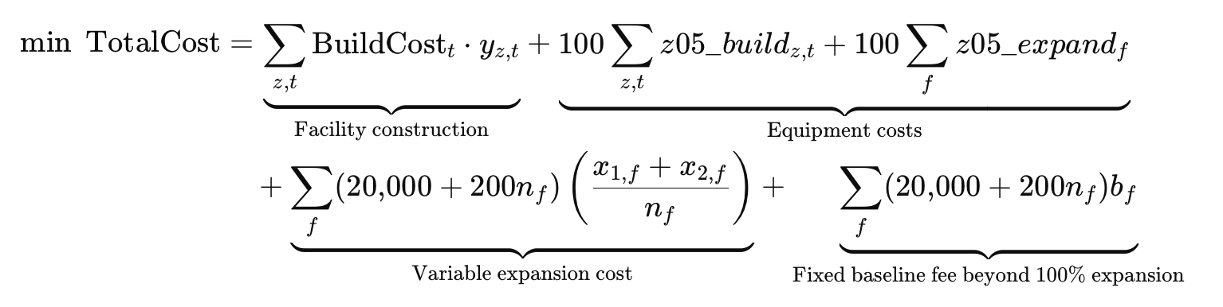

1.4 Constraints
- Expansion Limits
$$x_{1,f}≤n_{f}, x_{2,f}≤0.2 n_{f}, x_{2,f}≤0.2 n_{f} b_{f}, b_{f}∈\{0,1\}$$
- Age 0–5 Allocation
$z05_build_{z,t}≤\text{capacit}{\text{y}}_{\text{0-5,t}}· y_{z,t}, z05_expand_{f}≤x_{1,f}+x_{2,f}$​
- Coverage Requirements
For each ZIP z:
  - Age 0–12:
$\text{existin}{\text{g}}_{\text{0-12,z}}+\sum_{f∈z}{\left(x_{1,f}+x_{2,f}\right)}+\sum_{t}{\text{capacit}{\text{y}}_{\text{t}}} ·y_{z,t}≥\text{re}{\text{q}}_{\text{0-12,z}}$​
  - Age 0–5:
$$\text{existin}{\text{g}}_{\text{0-5,z}}+\sum_{f∈z}{z05_expand_{f}}+\sum_{t}{z05_build_{z,t}}≥\text{re}{\text{q}}_{\text{0-5,z}}$$

